Practical 21:

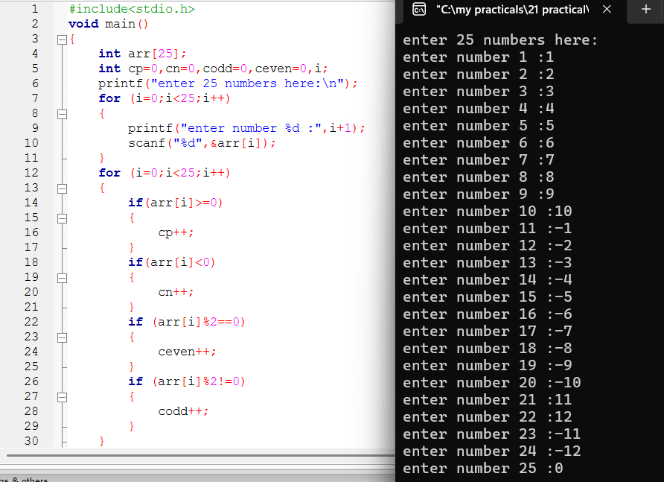

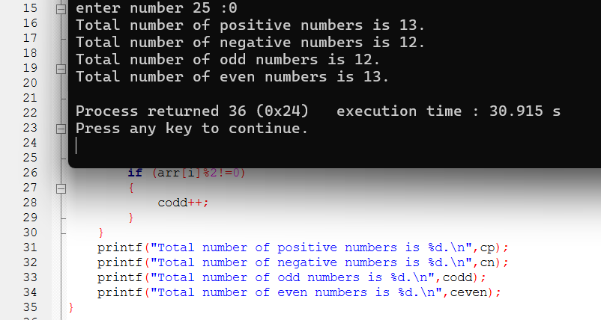

21-i:

21-ii:

